-PIP INSTALL MUNKIES

BILL OF MATERIALS

|  |  |  |  |  |  |
| --- | --- | --- | --- | --- | --- |
| **Component** | **Description** | **Quantity** | **Specification** | **Package type** | **Source** |
| ESP32-S3 | Wi-Fi+Bluetooth  Microcontroller | 1 | ESP32-S3-WROOM-  1-N16R8 | Module | Digikey |
| Gas Sensor | Air quality detection sensors | 1 | MQ-135 | Through-hole | Sparkfun |
| Sound Sensor | Detects sound intensity | 1 | KY-037 | Module | Digikey |
| IP5306 | Power Boost  Converter Module | 1 | IP5306 | Module | Digikey |
| TP4056 | Lithium battery charging module | 1 | TP4056 | Module | Digikey |
| IR Sensor | Infrared obstacle detection sensor | 1 | IR PROXIMITY SENSOR | Module | Robu.in |
| RTC Module(DS3231) | Real-time clock for timekeeping | 1 | DS3231 | Module | Digikey |
| Dust sensor | Air quality PM 2.5 & PM10 Detector | 1 | GP2Y1010AU0F | Module | Digikey |
| Hall Effect Sensor | Magnetic field sensor | 1 | A3144 | TO-92 | Robu.in |

|  |  |  |  |  |  |
| --- | --- | --- | --- | --- | --- |
| **Components** | **Description** | **Quantity** | **Specifications** | **Package type** | **Sources** |
| Waterflow sensor | Measure water flow rate | 1 | YF-S201 | Module | Robu.in |
| DHT11 | Temperature & Humidity sensor | 1 | DHT11 | Module | Digikey |
| Soil Moisture Sensor | Capacitive-based  moisture sensor | 1 | FC-28 | Module | Robu.in |
| Relay Module | Switches high power devices | 1 | SRD-05VDC-SL-C | Module | Digikey |
| Rain Sensor | Detects rainwater presence | 1 | YL-83 | Module | Robu.in |
| MAX471 | Current Sensor  module | 1 | MAX471 | Module | Sparkfun |

PCB LAYOUT

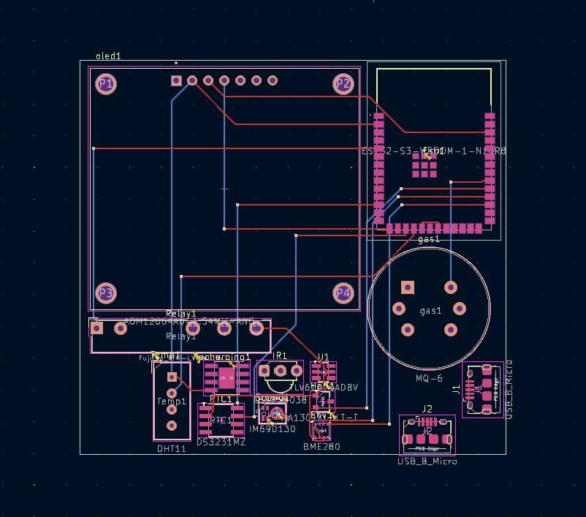

3D-RENDERED IMAGES OF PCB

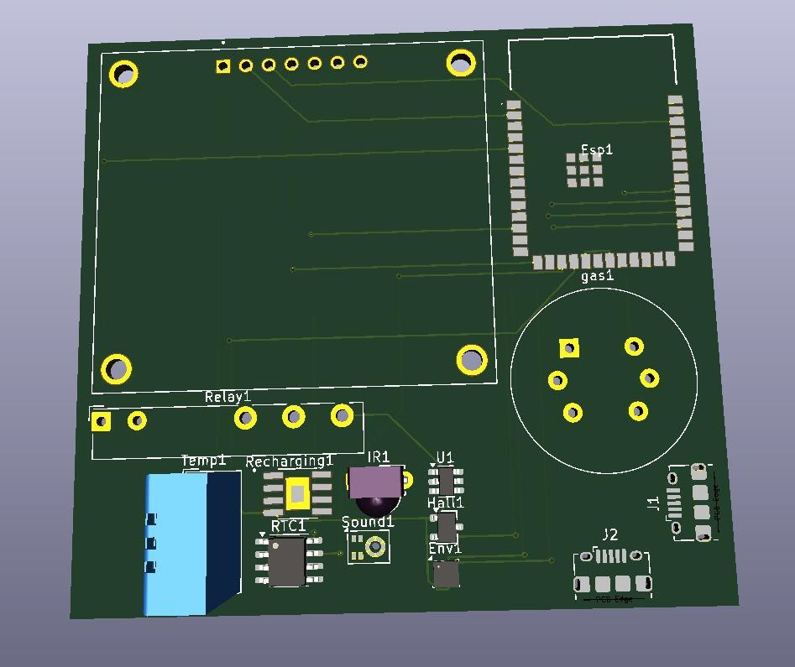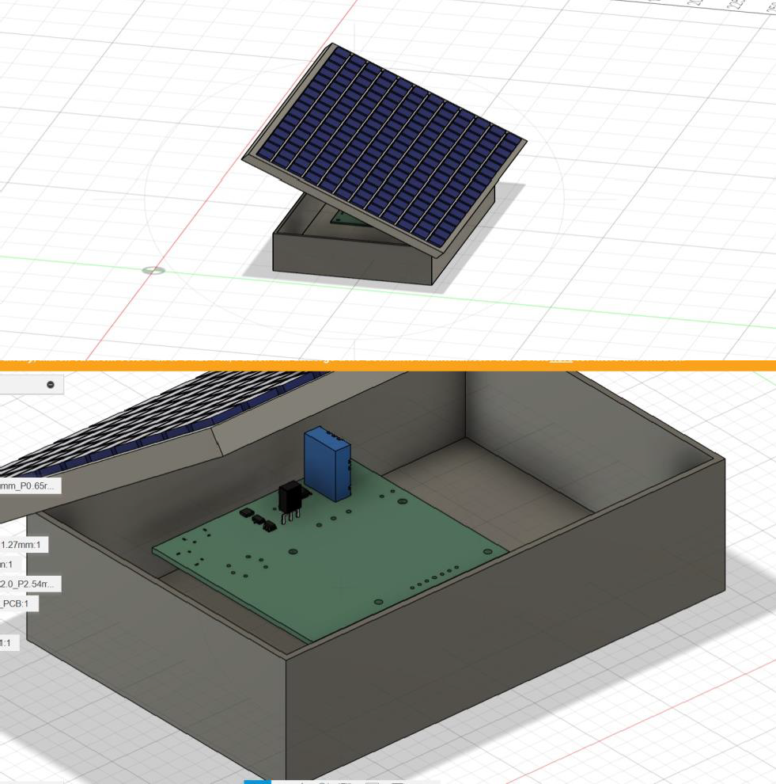

SCHEMATIC DIAGRAM

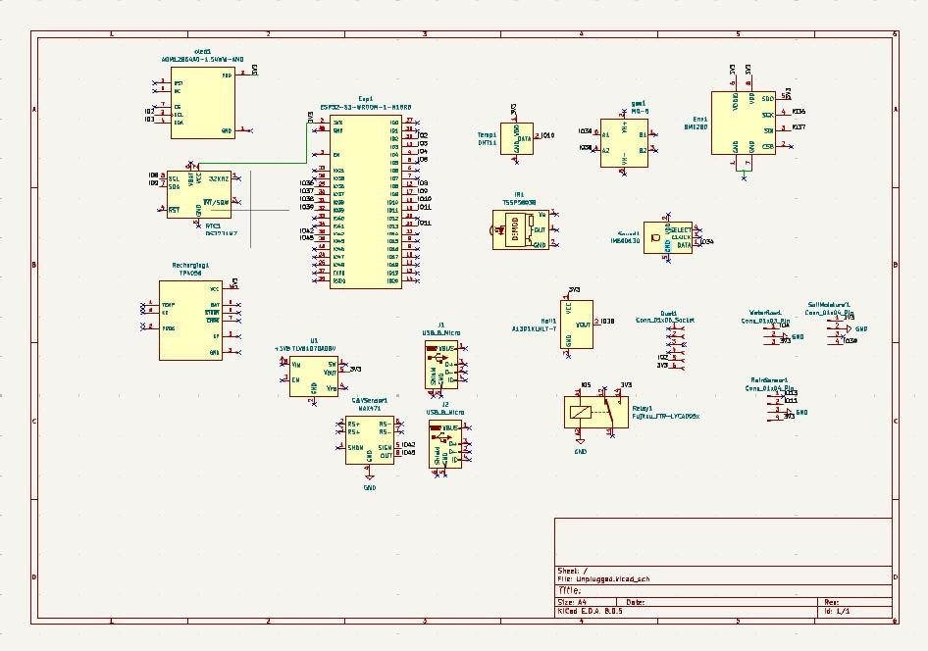

DESIGN RULE CHECK(DRC)

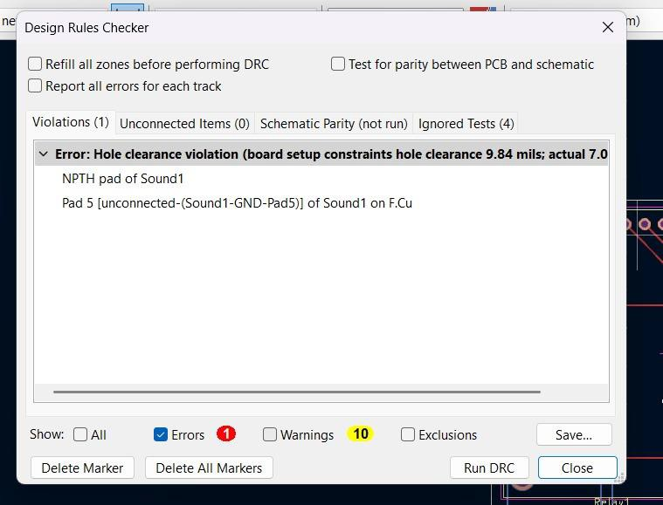

ELECTRICAL RULE CHECK(ERC)

